CHAPTER ONE

INTRODUCTION

1.1 Background of the Study
In the current digital era, security experts are increasingly concerned about phishing. This is owing to the fact that there is a high propensity and a comparatively simple way for attackers to produce phony websites that defaces its original counterpart. Phishing is a form of social engineering in which attackers impersonate a trusted organization or individual to trick users into divulging sensitive data - passwords banking credentials, or personal information. Phishing remains one of the most prevalent and financially damaging cybersecurity threats today; the FBI’s Internet Crime Complaint Center regularly reports more phishing incidents than any other category of cybercrime being responsible for an estimated USD 17.4 billion in global losses in 2024, a 45% increase over the previous year - 2023. Across all cyber-incidents, phishing features in 36% of breaches, while social engineering is implicated in over 80%. In 2025, the average cost of a phishing-related data breach is now nearly USD 4.9 million for affected organizations.
Although experts are able to recognize these fraudulent websites, many users are not, leaving them open to phishing scams. The following is a condensed description of how hackers execute phishing attacks: Usually, they send spam emails stating that your password for the university network is about to expire. The email provides a link to update your password, but clicking on it redirects you to a hacker-controlled server where they can steal your online data. In our project, we aim to predict whether a website is a phishing site or a legitimate one. We've collected the dataset from Kaggle^{[1]}. URLs with no malicious detection are labeled as '-1' (benign), while the detected ones are labeled as '1' (malicious).
We're exploring various machine learning algorithms to analyze the characteristics of these URLs. By understanding the features that indicate phishing, we hope to improve detection strategies. Phishing attacks often succeed due to a lack of consumer awareness, exploiting weaknesses in users.
Traditional detection methods - such as static rule-based heuristics and signature-based blacklists - are increasingly ineffective against zero-hour phishing campaigns, as newly created malicious URLs or obfuscated phishing sites can appear hours before appearing in any blacklist. Hence, Machine learning has emerged as a critical countermeasure and the greatest arsenal in an experts arsenal in this evolving landscape, and in the race against cyber-warfare.
One common technique to tackling this attack is updating blacklisted URLs and IPs in antivirus databases, known as the "blacklist" method. However, attackers constantly find ways to bypass blacklists through tactics like URL obfuscation, fast- flux (rapidly changing proxies), using homoglyph substitution, URL shortening, embedded IP addresses, algorithmically generating new URLs, and benign redirects to evade detection. To lure people in, phishers send mass emails, prompting users to visit a spoofed website. These sites often trick users into running software or downloading files. Malicious URLs can be detected using machine learning techniques, providing a more efficient solution compared to traditional methods. For better protection against phishing, it's essential for individuals to understand how these websites appear in their browsers. High-end companies can employ machine learning and deep neural network algorithms to proactively blacklist or detect phishing websites early. Machine learning helps catch phishing websites by learning from examples of both real and fake sites. It looks for signs like strange web addresses or tricky content that are common in phishing. Once it learns what to look for, it can quickly decide if a new website seems like a phishing threat or not. This smart system works faster than older ways of finding phishing sites, making it better at keeping users safe from online scams.
Essentially, machine learning acts like a smart detective that's always learning and staying one step ahead of the tricks that hackers use to create fake websites. Machine learning particularly URL-based detection, provides an effective countermeasure by analyzing URL lexical features in real-time. Leveraging meaningful features particularly from URL structures will aid ML-based systems in identifying malicious URLs in real-time, even before a page renders. Peer-reviewed studies confirm accuracy levels exceeding 97% using models like Random Forest, XGBoost, CatBoost, and Neural Networks, and LSTM Stacking. URL-based systems, by analyzing characteristics such as length, token patterns, special characters, IP address usage, and hyphen placement, enable lightweight yet robust phishing detection suited for deployment on server or client-side platforms.
Machine Learning in addition has proven to be the best approach to deal with such important aspects of Machine learning serves as a transformative paradigm in constructing real-life models by enabling computational systems to autonomously learn and derive insights from data, subsequently facilitating informed decision-making. This methodology obviates the need for explicit programming, allowing models to discern intricate patterns and extrapolate predictions. This project builds on these advances: constructing a robust and extensive URL-feature extraction pipeline, evaluating mutiple classifiers including but not limited to Extreme Gradient Boosting - XGBoost, and deploying a real-time Flask application.

1.2 Problem Definition
Online phishing is one of the most common attacks on the modern internet. Phishers use the sites which are visibly and semantically like those of authentic websites. Users frequently fall victim to phishing scam because malicious URLs often closely mimic benign websites. Despite evolving phishing tactics and increasing investments in cybersecurity, many cybersecurity solutions still depend heavily on blacklists, static heuristics or signature-based detection, incapable of identifying brand-new phishing sites, and unable to detect novel or short-lived phishing attempts effectively as phishing attacks continue to exploit user behaviour and system blindspots.
Such limitations leave users exposed in the “blind window” before listing in threat databases. Similarly, organizations remain vulnerable during the “listing window” when phishing URLs are newly created and not yet flagged in threat feeds. Moreover, attackers increasingly use techniques like homoglyph substitution, URL shortening, benign third-party redirection, hidden execution scripts, URL obfuscation, AI-generated spear-phishing, and dynamic content to bypass conventional defenses and evade naive detectors.
The problem is derived after making a thorough observation and study about the method of classification of phishing websites that makes use of machine learning techniques. This paper aims to answer the research problem below -
How can an effective, real-time phishing detection system be constructed using only URL-derived lexical features - capable of accurately identifying and classifying sites accurately immediately upon URL submission and supporting deployment in real-world environments?
This would be achieved by designing a system that should be able to:
- Accurately and efficiently classify the websites into legitimate or phishing.
- Time consumed for detection should be less and should be cost effective.

1.3 Aim and Objectives of Study
The aim of this study is to design, implement, and deploy an accurate, explainable, real-time phishing detection system by leveraging URL-based features and machine learning, capable of deployment via a web interface and resilient to emerging attack tactics. The specific objectives are:
- •Develop a comprehensive URL feature extraction pipeline capable of capturing lexical, structural, lexical attributes, and pattern-based features such as length, token counts, hyphens, presence of IPs/@ symbols, special characters, domain and path segmentation.
- •Train, validate, implement, and compare multiple supervised ML models, including Random Forest, Gradient Boosting (e.g., XGBoost), Support Vector Machine, Naives Bayes, K-NN, Logistic Regression, and MLP - selecting the best-performing model.
- •Use feature selection and explainable AI techniques (e.g;, Information Gain, feature importance ranking, SHAP or LIME, or recursive feature elimination) to prune, interpret model predictions, enhance trust and interpret feature importance for model explainability.
- •Containerize the chosen model and feature extraction system within a Flask application for URL submission and classification via an HTTPS endpoint.
- •Deploying the system using Render platform, enabling real-time access and testing.
- •Evaluating system and model performance using standard metrics - accuracy, precision, recall, F1-score, ROC/AUC - and compare across models and classifiers.
- •Assess system robustness to zero-hour and adversarial URL variants, analyzing potential weaknesses and mitigation strategies.

1.4 Research Justification
Phishing attacks accounts for significant financial, reputational, and operational risks worldwide - from individual users to multinational businesses and corporations billions yearly; notably, US businesses lost an estimated US $2 billion in a single year due to phishing-related fraud. As phishing-as-a-service (PhaaS) platforms proliferate, attack volumes and sophistication escalate rapidly. By 2025, cybercrime damages are projected to exceed USD 13.8 trillion, with phishing remaining a core driver. Business Email Compromise (BEC) alone caused USD 2.1 billion in financial losses in 2025 in the financial sector - 45% of which were phishing-initiated.
Machine learning offers adaptive and scalable detection, offering agility over traditional-signature or rule-based defenses by learning from patterns in data and adapting to new attack tactics. Research shows ensemble methods like Random Forest or XGBoost consistently outperform simple classifiers, reaching upwards of 99% accuracy on balanced datasets. While deep learning models (e.g., Bi-LSTM, stacking) show high accuracy (>96%), they often operate as opaque black boxes. Integrating explainability tools like SHAP or LIME - as explored in frameworks such as EXPLICATE, which achieved 98.4% accuracy with user-friendly natural language explanations - bridges the gap between automation and trust.
Furthermore, feature selection and explainability frameworks (e.g. SHAP) are critical to ensuring trustworthy ML-based systems that are crucial in cybersecurity applications where transparency and auditability are vital. Given the dynamic nature of phishing, a deployed real-time system using URL features alone provides a fast, lightweight, and scalable solution for organizations, especially in resource-constrained settings. The approach I employ emphasizes not only robust detection accuracy, but also interpretability and live deployment. For award-level research, this blend of technical rigor, transparency, and practically offers significant impact. It builds on a robust dataset and evaluated models, directly addresses these real-world needs.

1.5 Scope of Study
In this project, the primary focus has been on leveraging machine learning techniques and deep learning techniques to assess and detect phishing websites with binary classification of links as either "legitimate" or "phishing" based solely on URL-derived features and some HTML (version 5.0) hyperlink attributes. The core of our approach lies in the utilization of various algorithms for training and prediction purposes. To implement this, we have employed the Flask framework, a powerful Python web framework, and seamlessly integrated multiple libraries catering to diverse functionalities. Our choice of algorithms encompasses a comprehensive set, including Random Forest, Decision Tree, Support Vector Machine (SVM), K-Nearest Neighbor, Naive Bayes, Gradient Boost and Multi-layer Perceptron. These algorithms serve as the backbone of our predictive model each contributing unique strengths to the overall accuracy of link classification with performance benchmarking across metrics and feature selection experiments.

The implementation involves a two-step process: training the algorithms on a labeled dataset to learn the patterns associated with good and bad links, and subsequently, utilizing trained models for real-time prediction of new links. By employing this combination of machine learning algorithms and performance evaluation metrics, we aim to provide a robust and accurate solution for link classification, ensuring the reliability and efficiency of our system in distinguishing between good and bad links, including detection accuracy, explainability insights (feature importance), and preliminary resilience against evasion and adversarial perturbations.
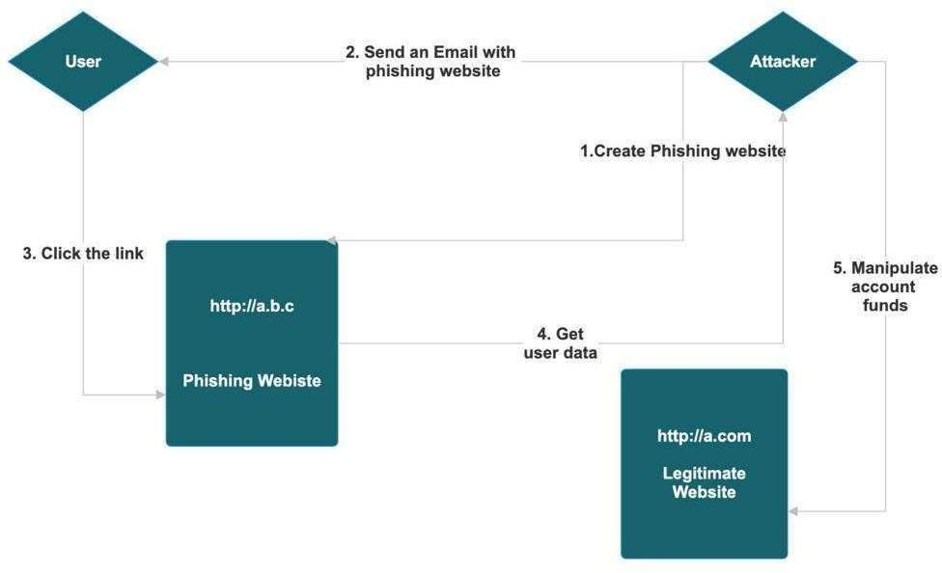

Figure 1.5 Flow of Methodology

1.6 Limitation of Study
However, the study has limitations. It relies on URL-based features only; as a result, complex content analysis or behavioral metrics are not included. The exclusion of content-based or contextual features (e.g., page rendering, WHOIS metadata) may limit detection of advanced evasive techniques like benign redirect loops or dynamically generated phishing pages. Furthermore, the reliance on URL-derived features excludes detection of phishing hosted behind benign redirects or when attackers employ homograph attacks or dynamically rendered JavaScript content.
Also, model performance is limited by the representativeness and balance of the dataset as zero-hour detection efficacy is limited by dataset diversity and adversarial evasion still remains a risk, so dependence on dataset quality and representativeness may affect performance on unseen phishing variants. In addition to that, adversarial attacks (e.g., URL obfuscation, poisoning) may bypass models without additional mitigation (e.g., adversarial training or ensemble defenses). Lastly, the lack of integration with external context (e.g., domain reputation, WHOIS, hosting IP geolocation) reduces detection depth.

1.7 Definition of Terms
- •Phishing: A fraudulent attempt to obtain sensitive information by impersonating or masquerading a trustworthy or trusted entity, typically via deceptive URLs, emails or smishing (SMS Phishing) and other communication channels.
- •Zero-Hour Phishing: Newly launched phishing sites that emerge before they appear in blacklists. They are undetected by blacklists at the time of creation or by current threat intelligence feeds.
- •Lexical URL Features: Structural and textual traits or characteristics derived directly from the composition of the URL string (e.g., token counts, length metrics, presence of special symbols or IP addresses).
- •Explainable AI (XAI): Techniques like SHAP or LIME that expose the contribution of individual features to model predictions, enhancing transparency and trust. They are also methods used to interpret model predictions and understand which features derive decisions.
- •Adversarial Machine Learning: Techniques attackers use to manipulate input - URLs - to cause misclassification; includes homoglyph substitution and URL obfuscation.
- •Machine Learning (ML): A subset of AI using algorithms to learn from data for the purpose of classification or prediction.
- •Feature Extraction: Process of converting raw URLs into measurable patterns (e.g., number of dots, special symbols, length metrics, etc.
- •Gradient Boosting / Random Forest: Ensemble ML algorithms that build strong classifiers from multiple decision trees.
- •Flask: A lightweight Python micro-framework used to create a web-based API/UI for real-time URL classification by supporting Rapid Application Development (RAD).
- •Render: A fully-managed cloud application platform designed to simplify deployment and hosting for developers that supports web applications, static sites, and databases.

1.8 Chapter Layout
CHAPTER 1 - INTRODUCTION
•This chapter serves as a project and launching pad to provide a comprehensive background for secure cloud backup and recovery. It includes an introduction to the project, defines the problem, outlines the objectives, reflects the purpose and motivation of the project and decides the organization of the project preview report.
CHAPTER 2 - LITERATURE REVIEW
•This chapter focuses on extensive research and integrates information from a variety of reputable sources, including standard books, journals, websites, and technical publications. The pertinent literature is printed, prior research on the subject is highlighted, and vital traits in cloud storage, backup, healing, and encryption are mentioned.
CHAPTER 3 - SYSTEM ANALYSIS AND DESIGN METHODOLOGY
•This chapter discusses the technical additives in the order of requirements and evaluation, venture planning, and architecture. It covers the statistics education and implementation system and introduces the most vital parts which include code samples, algorithms, equipment and strategies. The fundamental difficulties of the development procedure and the way to remedy them are also examined.
CHAPTER 4 - SYSTEM IMPLEMENTATION
•This chapter discusses the trying out technique, emphasizing the devices and strategies used to evaluate the platform and its performance, emphasizing the platform and ensuring reliability. It presents a thorough evaluation of the system with the aid of supplying a summary of take a look at instances and their outcomes.
CHAPTER 5 - SUMMARY, CONCLUSION AND RECOMMENDATIONS
•This insightful chapter provides an overview of the project and key findings, limitations and industry contributions. It follows with recommendations for future research pathways, paving the way for more investigation and innovation by providing guidelines for fine-tuning testing procedures, investigating additional performance indicators, and addressing outstanding problems.

